|  |  |  |  |
| --- | --- | --- | --- |
| **ΤΜΗΜΑ** | **ΑΓΩΝΑΣ** | **ΓΗΠΕΔΟ** | **ΑΠΟΤΕΛΕΣΜΑ** |
|  |  |  |  |
| **ΗΜΕΡΟΜΗΝΙΑ** | **ΠΡΟΠΟΝΗΤΗΣ ΓΗΠΕΔΟΥΧΟΥ** | **ΠΡΟΠΟΝΗΤΗΣ ΦΙΛΟΞΕΝΟΥΜΕΝΩΝ** | **ΔΙΟΡΓΑΝΩΣΗ** |
|  |  |  |  |

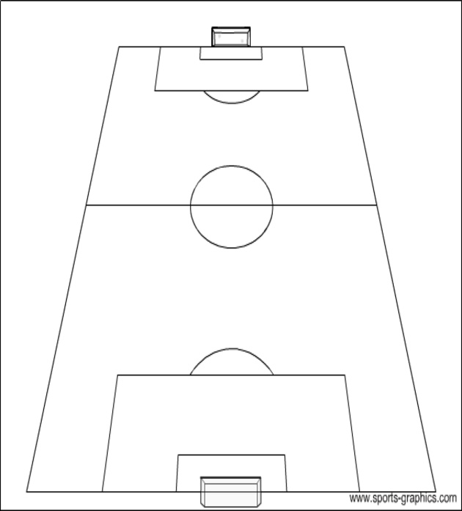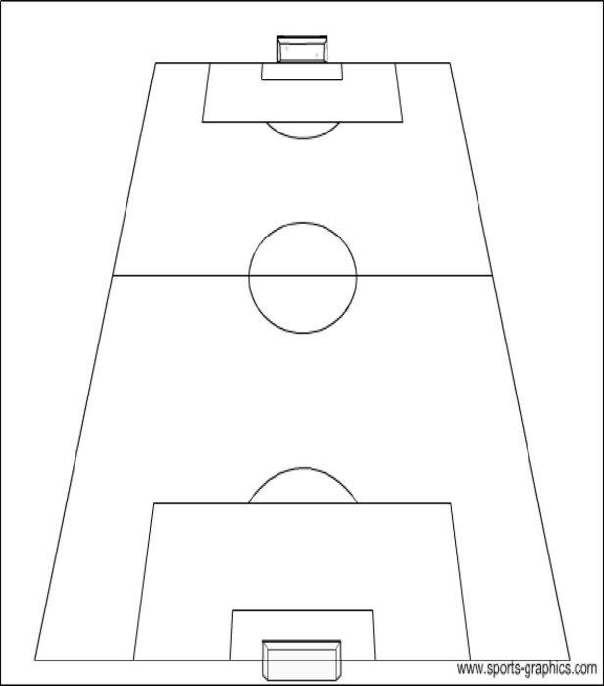

|  |  |  |  |  |  |
| --- | --- | --- | --- | --- | --- |
| **ΑΡ. ΦΑΝ.** | **ΓΗΠΕΔΟΥΧΟΣ** | **ΗΜ. ΓΕΝ.** | **ΑΡ. ΦΑΝ.** | **ΦΙΛΟΞΕΝΟΥΜΕΝΟΙ** | **ΗΜ. ΓΕΝ.** |
|  |  |  |  |  |  |
|  |  |  |  |  |  |
|  |  |  |  |  |  |
|  |  |  |  |  |  |
|  |  |  |  |  |  |
|  |  |  |  |  |  |
|  |  |  |  |  |  |
|  |  |  |  |  |  |
|  |  |  |  |  |  |
|  |  |  |  |  |  |
|  |  |  |  |  |  |
|  |  |  |  |  |  |
|  |  |  |  |  |  |
|  |  |  |  |  |  |
|  |  |  |  |  |  |
|  |  |  |  |  |  |
|  |  |  |  |  |  |
|  |  |  |  |  |  |
|  |  |  |  |  |  |

|  |
| --- |
| **ΓΕΝΙΚΕΣ ΠΑΡΑΤΗΡΗΣΕΙΣ :** |